1. Assign value labels

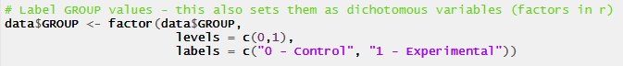

1. Standardize continuous variables  
     
   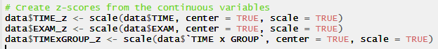  
     
   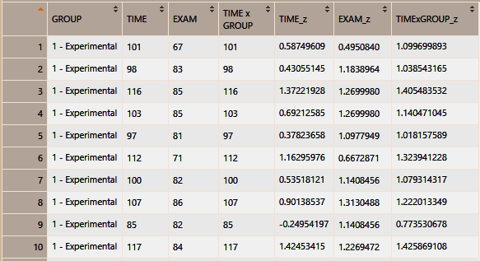
2. Prepare interaction scatterplot



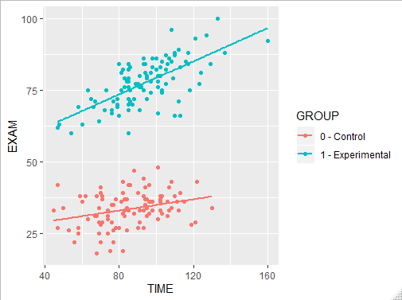

1. Conduct test of coincidence  
     
   If you are using SAS, this will do the trick:  proc reg data=Zs PLOTS=none; model Exam = Group Time Interaction; TEST Group=0, Interaction=0;  
   Title1 "Test of Coincidence %ST"; run; QUIT;

• If the test of coincidence is not significant, drop the interaction term from the model and conduct an analysis of covariance.  If you are using SAS, this would do the trick:  Proc GLM data=Zs; Class Group; Model Exam = Time Group / ss3; LSMeans Group; format Group gr. ;

• If the test of coincidence is significant, report the tests of slopes and the test of intercepts.  If you are using SAS, these will be available in the GLM output used to test coincidence.

• If the test of slopes is significant, probe the interaction by testing the simple effects of time by group.  Process Hayes will give you these.

• Test the unconditional effects.  Do the groups differ on exam performance (independent samples *t* test).  Is the zero-order correlation between study time and exam performance significant?